**Common Standards for Water Data Platform**

***Minimum Requirements***

# Scope

This document is intended to capture the minimum requirements of datasets to enable integration and reconciliation with existing datasets within the NM Water Data Platform (powered by CKAN). The details below capture the specific details of the integrated datasets; details regarding how existing entries were mapped onto a common taxonomy are captured in Appendix A.

Numerous types of data exist related to water, including details about specific locations, infrastructure details, water quality, water quantity, etc. Given that all water data is geospatially-grounded, we break down requirements into both location details (including specific sites) and different activity measurements.

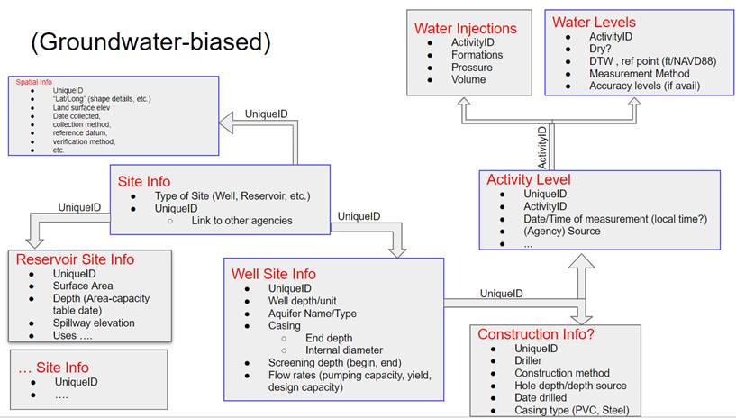

TG to do: Need to refine visual to have a minimum data requirements and an ideal data version. Add time zone

# Location Details

|  |  |
| --- | --- |
| **Base** | **Description** |
| Agency Code | Agency Name |
| Site Number | Site Number |
| Site Name | Site Name |
| Latitude/Longitude | Latitude/Longitude |
| Horizontal Datum | Horizontal Datum |
| Altitude | Altitude |
| Site Type | Well, etc. |

# Site-Specific Details

## Wells

|  |  |
| --- | --- |
| **Column** | **Description** |
| Site No | Site No |
| Well Depth | Well Depth |
| Aquifer Name/Type | Aquifer Name/Type |
| Casing (end depth) | Casing (end depth) |
| Casing (internal diameter) | Casing (internal diameter) |
| Screening depth (begin – end) | Screening depth (begin – end) |
| Flow rates | Flow rates |
| Well Type | Monitoring, Pumping, Injection, etc. |

# Activities

## Water Level Measurements

|  |  |
| --- | --- |
| **Column** | **Description** |
| Agency Cd | Agency Cd |
| Site No | Site No |
| Time | Time. |
| TimeZone | MDT vs. MST |
| Date | Date |
| Depth to Water Below Land Surface in ft | Depth to Water Below Land Surface in ft |
| Measuring point height (relative to land surface) | Measuring point height (relative to land surface) |
| Accuracy Value | Accuracy Value |
| Water level in feet relative to NAVD88 | Water level in feet relative to NAVD88 |
| Observation Method | Observation Method |
| Level Status | Pumping or obstruction, etc. |

**Appendix A: Crosswalk**

|  |  |  |  |  |
| --- | --- | --- | --- | --- |
| **Recommended Standard (NGWMN)** | **USGS** | **NMBGMR** | **ABQ** | **OSE** |
| Agency Cd | agency_cd | NMBGMR | ABQ | OSE |
| Site No | site_no | PointID | sys_loc_code |  |
|  |  | OSEWellID |  | OSE Well # |
| Agency Nm | United States Geological Survey | New Mexico Bureau of Geology & Mineral Resources | NEED NAME | Office of State Engineer |
| Site Name | station_nm | SiteID | loc_name |  |
| Dec Lat Va | dec_lat_va | Geometry | latitude | Latitude |
| Dec Long Va | dec_long_va | Geometry | longitude | Longitude |
| Horz Datum | dec_coord_datum_cd | Need |  |  |
| Alt Va | alt_va | Altitude | exact_elev | Groundwater Elevation |
| Alt Datum Cd | alt_datum_cd | Need |  |  |
| Well Depth | well_depth_va | WellDepth | measured_depth_of_well | Total Depth (feet) |
| Site Type | site_tp_cd | Need |  |  |

|  |  |  |  |  |
| --- | --- | --- | --- | --- |
| **Recommended Standard (NGWMN)** | **USGS** | **NMBGMR** | **ABQ** | **OSE** |
| Agency Cd | agency_cd | Calculate in crosswalk | Calculate in crosswalk | Calculate in crosswalk |
| Site No | site_no | PointID | sys_loc_code |  |
|  |  | OSEWellID | facility_id | OSE Well # |
| Time | lev_tm | TimeMeasured |  | Time |
| Date | lev_dt | DateMeasured | measurement_date | Date |
| Depth to Water Below Land Surface in ft | lev_va | DepthToWaterBGS | water_level | Depth to Water (feet below ground surface) |
| Accuracy Value | lev_acy_cd | Need |  |  |
| Water level in feet relative to NAVD88 | Calculate in crosswalk | Calculate in crosswalk | Calculate in crosswalk | Calculate in crosswalk |
| Observation Method | lev_meth_cd | MeasurementMethod | measurement_method |  |